**How to Use this Template**

1. Create a new document, and copy and paste the text from this template into your new document [ Select All → Copy → Paste into new document ]
2. Name your document file: “**Capstone_Stage1**”
3. Replace the text in green

Description

Intended User

Features

User Interface Mocks

Screen 1: Map / Main

Screen 2: Search

Screen 3: Directions

Screen 4: Trip details

Screen 5: Stop details

Screen 7: Line planning

Screen 8: Menu

Screen 9: Newsfeed screen

Screen 10: Alarms screen

Screen 7: List Screen

Key Considerations

How will your app handle data persistence?

API Temps Reel Tisseo – Real Time Tisseo API

Describe any libraries you’ll be using and share your reasoning for including them.

Describe how you will implement Google Play Services or other external services.

Next Steps: Required Tasks

Task 1: Project Setup

Task 2: Create the Java Model for the API

Task 3: Design the Database to save the information.

Task 4: Networking utilities

Task 5: Create the Main Activity

Task 6: Create the Login Activity

Task 7: Create the Map Activity

Task 6: Create the Login Activity

Task 6: Create the Login Activity

**GitHub Username**: electromedico

On y Va ( French for Lets Go)

# Description

Tired of waiting for the bus to pass by? You are not sure which is the best way to your destination?

On y Va helps plan your plan your daily trips with real time information from public transportation in Toulouse. We will guide you thru the entire trip with notifications so you don’t miss the next bus and we will tell you when to get off. Also our special feature start walking alarm. You lets know at what time you want to start your trip, and we will send you a notification when you need to start walking to the stop. This way you don’t have to worry about checking the time every five minutes (we will do that for you)

# Intended User

This app is intended to anyone using the public transportation in Toulouse.

# Features

* Plan your trip and get directions
* Nearby stations
* Line information
* Favorites
* Daily trips alarms
* Traffic news

# User Interface Mocks

These can be created by hand (take a photo of your drawings and insert them in this flow), or using a program like Google Drawings, [www.ninjamock.com](http://www.ninjamock.com), Paper by 53, Photoshop or Balsamiq.

## Screen 1: Map / Main

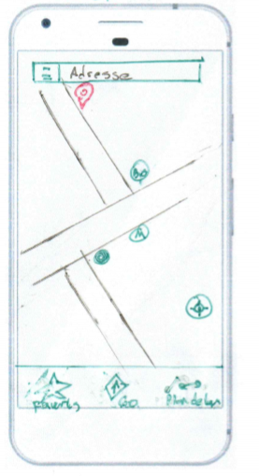

Main screen for the app. Here we will have the map with all the nearby stations, the toolbar with a search field and a buttons for the menu.

A FAB for finding your current location in the map

At the bottom we will have the buttons to access the favorites, the line planning and to start the trip.

If you click once in the map everything except the FAB will hide.

## Screen 2: Search

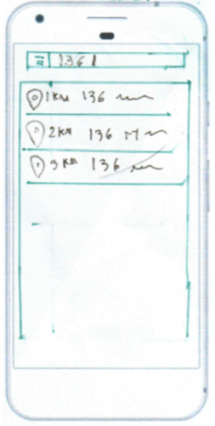

Here the user can search for an address or points of interests. It will automatically update as the user continues to tap the information

Also the App will propose recants trips

## Screen 3: Directions

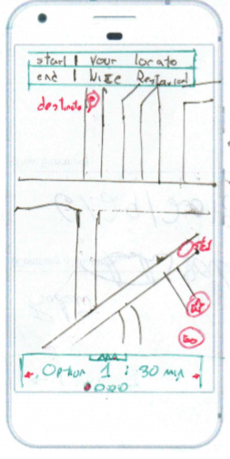

When: NOW

Here the User can see the starting and ending point of his trip. He also can chose at what time to start the trip

Also at the bottom if any, the user can chose from several options.

Two FAB buttons, one to add the trip to favorites and the other to start the trip.

## Screen 4: Trip details

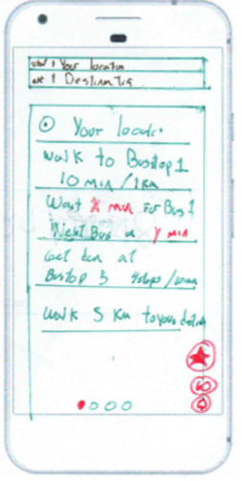

If the user taps in the option tab at the bottom of the previous screen or swipes up, the app will show the details of the trip.

Also the user can swipe left or right to see the other options.

The FAB buttons allow to save in favorites, start the trip and to set an alarm to get notified when to go.

## Screen 5: Stop details

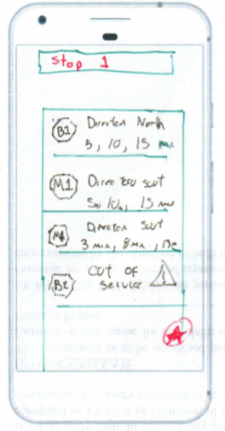

This screen will be shown when the user taps in a station in the map. Here the user can see all the information regarding the stop.

There is a FAB that allows the user to add to favorites the stop.

## Screen 7: Line planning

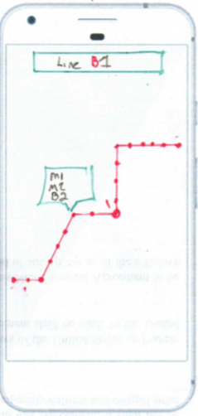

This screen will show in the map all the line including all the stops. Also if the user taps in one a pop up will show all the information regarding the stop.

## Screen 8: Menu

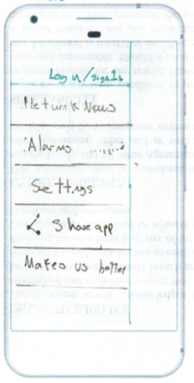

This screen will show the buttons for accessing the networks newsfeed, alarms, settings, share the app and a comments section.

## Screen 9: Newsfeed screen

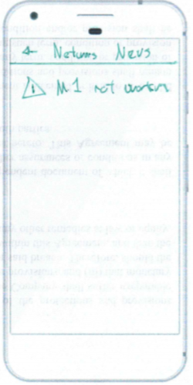

This screen will show all the news and info from the public transport network.

## Screen 10: Alarms screen

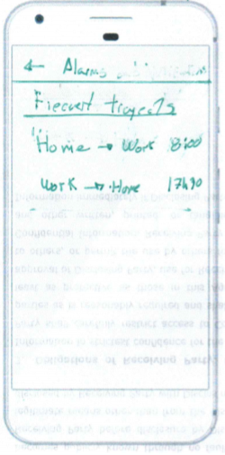

This screen will show all the alarms the user has saved and will allow him to manage them.

## Screen 11: List Screen

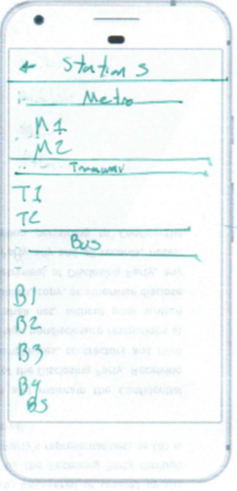

This screen will show a list of all lines. This will be reutilized by favorites and the list of all the stations.

## Screen 12: Log in Screen

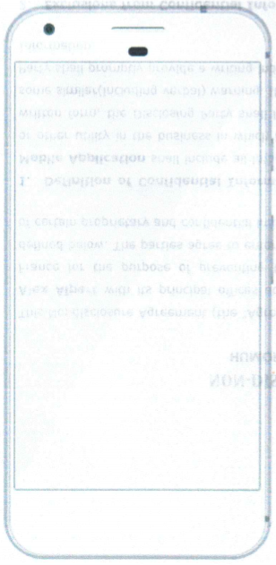

SKIP

G+ Log in

ON Y Va

In this screen the app will give the option to log in or to skip the log on. This screen will be only shown the first time the app is launched

# Key Considerations

### How will your app handle data persistence?

We will use a two different ways to store data. One will be used via a local database and a content provider.

If the users has log in with a google account, we will store the information in a Firebase Real-time database.

### API Temps Reel Tisseo – Real Time Tisseo API

We will the API to feed the app. The API is part of the OpenData of the region.

### Describe any libraries you’ll be using and share your reasoning for including them.

Retrofit will be use to manage the access to the REST API.

Google Maps Platform will be used for all treatment related to the map.

Schematic will be used to generate the database and the content provider.

ButterKnife will be used to inject the views.

Gson to transform the JSON into objects

### Describe how you will implement Google Play Services or other external services.

As expressed before we will use the firebase Real time data base to make a backup the information of the user.

The log in function will be managed via Google Sing in.

The most important part of this app is the maps capabilities. For this we will use google maps.

# Next Steps: Required Tasks

This is the section where you can take the main features of your app (declared above) and break them down into tangible technical tasks that you can complete one at a time until you have a finished app.

## Task 1: Project Setup

Starting point, it will lay out all the foundations for the app.

* Create a new project in Android Studio
* Create a new repository in GitHub
* Push the initial commit
* Set up all the libraries
* Add the permissions to the manifest
* Sing up for all the APIs and get the keys.
* Add all the image resources(icons, logos)
* Commit and Push all the changes.

## Task 2: Create the Java Model for the API

Create the Java model of the API

* Get the JSON model for API Temps Reel Tisseo
* Use JSONSCHEMA2POJO to generate the Java model. It’s important to make the classes Serializable or Parceable.
* Commit and push

## Task 3: Design the Database to save the information.

Design and implement the database for the app. This will be a single table containing all the specific information (favorites, alarms, and preferences)

* Create the package contentProviderUtils
* Here we will implement the Model class for the database
* Next we will use schematic for generating the content provider and the database.
* Add all the necessary information to the manifest.
* Create the utility class or interface to access the database.
* Commit and Push

## Task 4: Networking utilities

In this task we will set up and add all the utilities classes to access the REST services

* Create the networkUtils package
* Create the API declaration interface
* Create the utility class for the network package
* Commit and Push

## Task 5: Create the Main Activity

In this activity we will verify if the user is already logged in or if it is the first time the app has been launched

* If it is the first time, the app will call the log-in activity
* If not, the app will call the map activity.
* Commit and push

## Task 6: Create the Login Activity

Implementation of the login screen. The user will have the option to login with his google account or continue without login.

If he decides not to log, a popup will be shown that his information will not be backed up. If the user chooses to log, the app will launch automatic the Google Sign-in API. This screen will only be shown the first time the user launches the APP. Otherwise we will arrive to the map screen.

* Create LogInActivity.
* Implement google Sign-in
* Create the layout
* Commit and push

## Task 7: Create the Map Activity

In this activity we will get the current location, and then load all nearby stations.

Then we will add the markers to the map. Basic navigation functionality will be implemented.

If the user zooms out enough the stations markers will be gone leaving only the current location marker.

* Create MapActivity
* Implement google maps.
* Code all listeners for the buttons.
* Implement all the transitions so the app feels natural when launching a new activity
* Create the map_activity_layout
* Commit and Push

## Task 8: Create the Search Activity

This activity will use google maps and the tisseo API to locate the point of intererst searched by the user. It will show real time search and will propose points matching the query.

* Create the SearchActivity
* Implement the Search Overview
* Create the search_activity_layout
* Implement the transition to make it look that the user has returned to the map screen.
* Commit and push.

## Task 9: Create the Directions Activity

This activity will show the trajectory for the proposed trip. At the top we will see the starting and ending point. At the bottom of the screen the user will have a list of possible routes. Each time a new route is chosen, the app automatically updates the trajectory. If the user swipes up the app will transition to the trip details giving the impression that the screen is just on top of the map.

* Create DirectionsMapActivity.
* Implement google maps
* Query the base for the trajectory
* Map it
* Implement the trajectory list to look like a pager
* Add actions for the FABs
* Create the directions_map_activity_layout

Add as many tasks as you need to complete your app.

**Submission Instructions**

* After you’ve completed all the sections, download this document as a PDF [ File → Download as PDF ]
  + Make sure the PDF is named “**Capstone_Stage1.pdf**”
* Submit the PDF as a zip or in a GitHub project repo using the project submission portal

If using GitHub:

* Create a new GitHub repo for the capstone. Name it “**Capstone Project**”
* Add this document to your repo. Make sure it’s named “**Capstone_Stage1.pdf**”